|  |  |  |  |
| --- | --- | --- | --- |
|  | Bansilal Ramnath Agarwal Charitable Trust's  Vishwakarma Institute of Information Technology  **Department of**  **Artificial Intelligence and Data Science** | | |
| Student Name:Siddhesh Dilip Khairnar | | | |
| Class: SY | Division: B | | Roll No:272028 |
| Semester: III | | Academic Year:2022-23 | |
| Subject Name & Code: DBMS, ADUA21204 | | | |
| Title of Assignment:Write a PL/SQL code to implement all types of cursors and display employee number, name and salary of 5 highest paid employees using cursor. | | | |
| Date of Performance: 09-11-2022 | | Date of Submission: 16-11-2022 | |

**Aim: Write a PL/SQL code to implement all types of cursors and display employee number, name and salary of 5 highest paid employees using cursor.**

**Problem Statement**: Write a PL/SQL code to implement all types of cursors (Implicit, Explicit) and display employee number, name and salary of 5 highest paid employees using cursor. Employee (employeeno, employeename, join_date, designation, salary)

**Background information:**

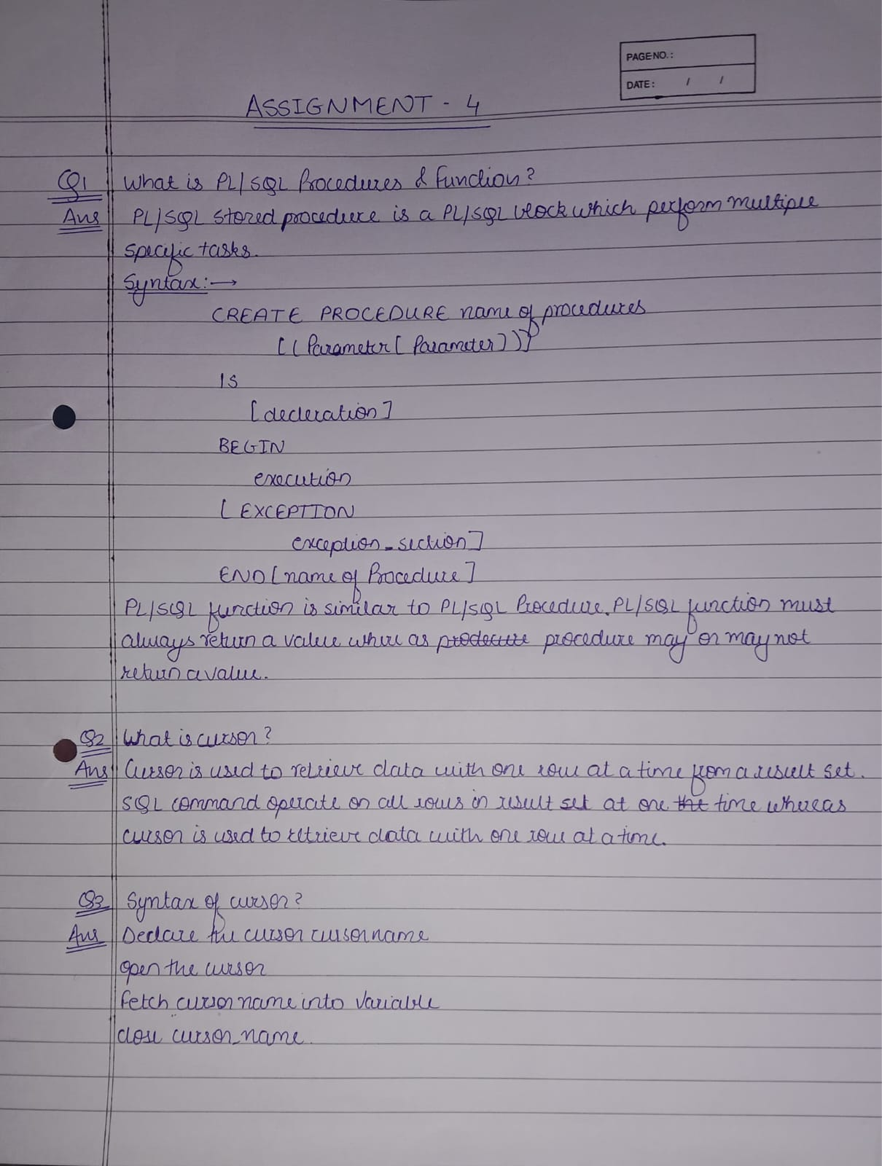

**Software Requirements**: MYSQL Shell

**C!** X

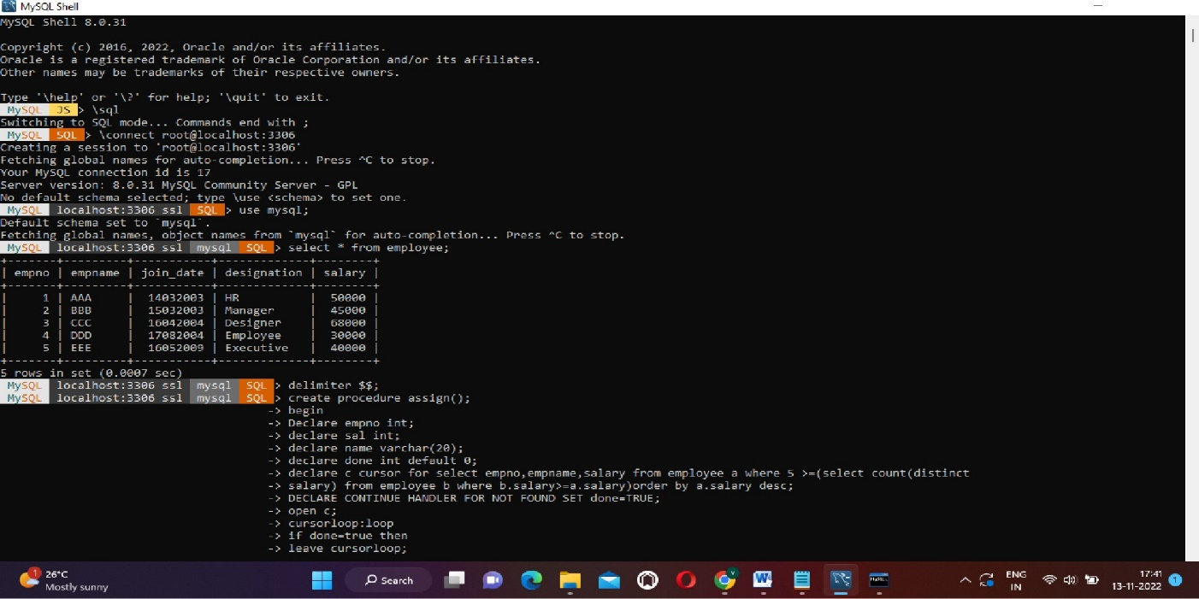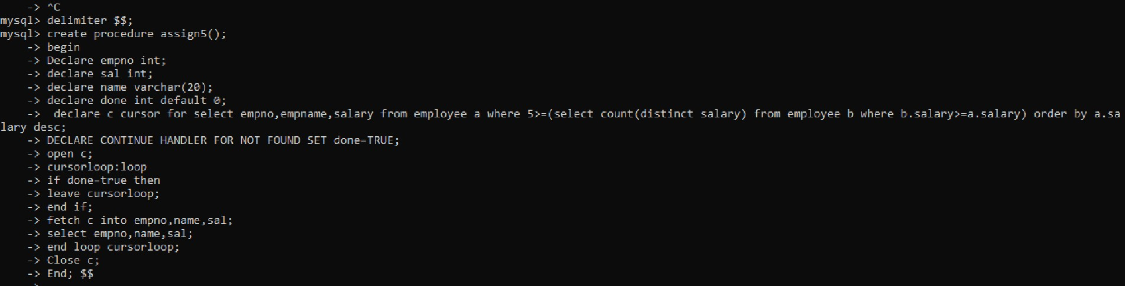**Program code with experimental result:**

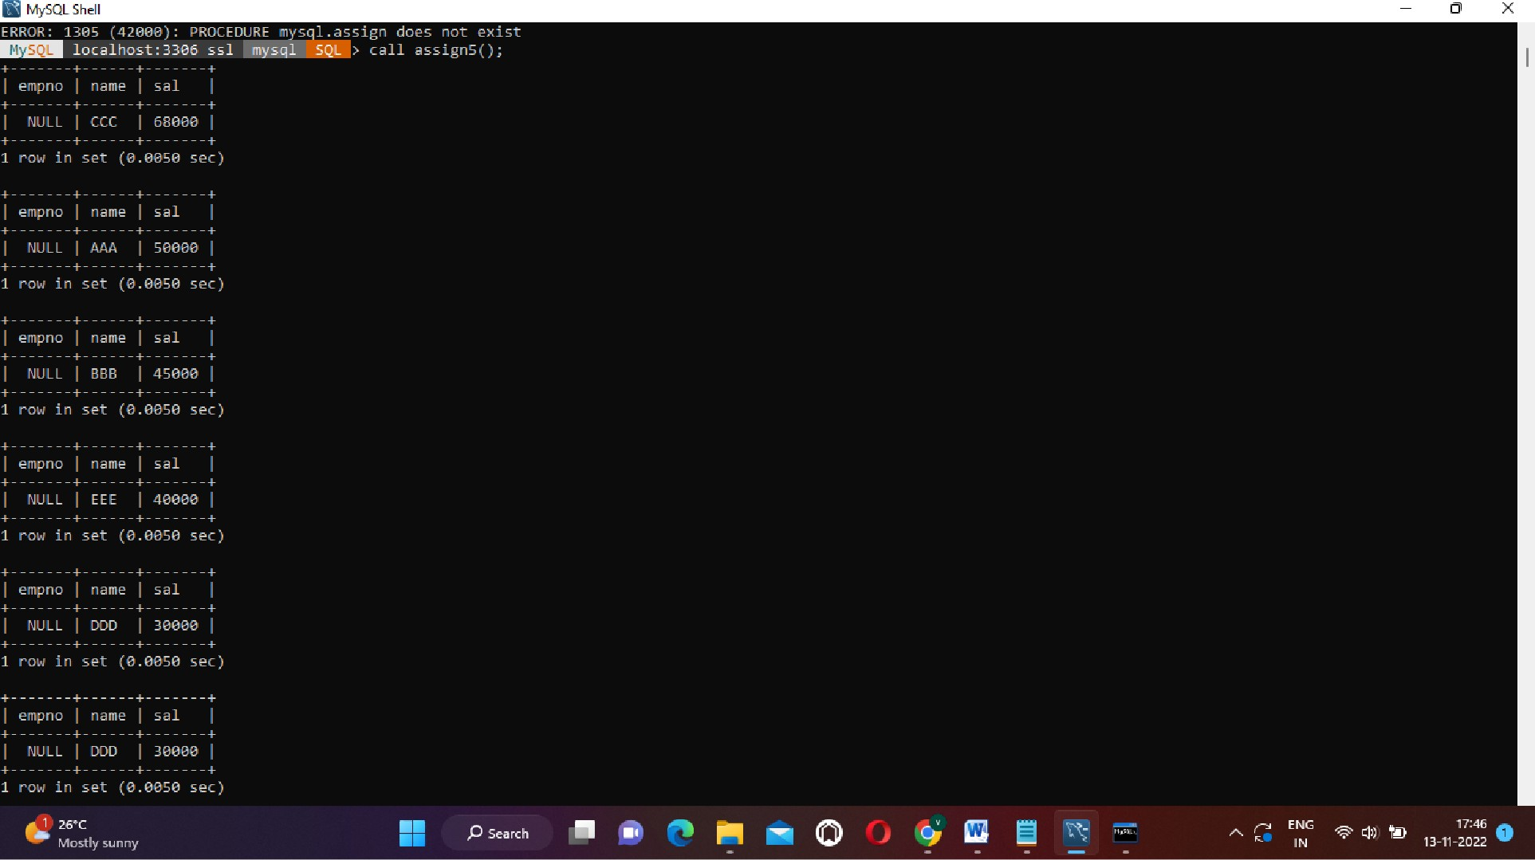

**Conclusion:** From this assignment I learned how to Use pl/SQL and cursor and form queries to have desired output